Meeting Minutes –Group 1

**Meeting No:** 1

**Location:** Room 111

**Date:** 9 September 2015

**Time:** 45 minutes

**Reporter**: Nguyễn Trung Nam

## Attendance

1. Kiều Trọng Khánh
2. Huỳnh Quang Thảo
3. Trần Thanh Ngoan
4. Nguyễn Trung Nam
5. Ngô Tiến Đạt

## Action Items

1. **Capstone Plan**

* w1d2: introdution, fix scope.
* w2d1: project plan.
* w2d2 – w4d1: SRS/coding.
* w4d2 – w6d2: coding(verify).
* w7 – w10: coding and SDD.
* w11 – w12: rehearsal, coding and testing.
* w12 – w13: document, complete.
* w14: coding, modifying, presentation.

1. **Core Scope:**
2. 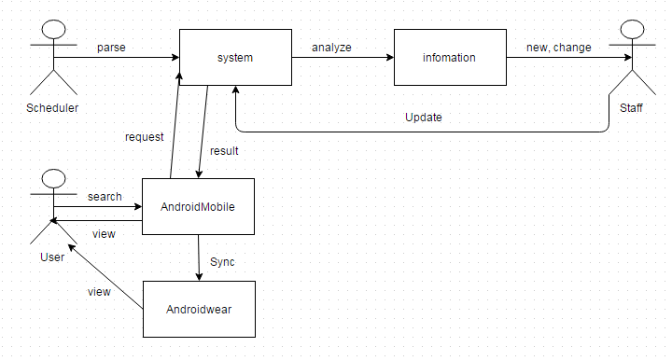**Discussion about scope:**
3. **Discussion about algorithm.**

* Best distance of two point.
* Best distance of four point:
  + One point start, one point end and random two point.
  + One point start, unknown point end of three.

1. **Next meeting: Friday, 11 September, 2015**

* Introdution.
* Fix scope.

|  |  |  |  |
| --- | --- | --- | --- |
| Owner | Item | Deadline | Status |
| Thảo | HTML user page | Next week | In progress |
| Ngoan | HTML admin page, edit report 2, mobile user prototype | Next week | In progress |
| Nam | HTML public page + use case spec. | Next week | In progress |
| Đạt | Use case spec | Next week | In progress |

**Other Notes:**

* How to auto collect information of bus routes when web change?
* Should user save history on mobile or wear?